Data Science Career Track

Capstone 2 -

Milestone 1 Report

by Edward Franke

05/26/2019

Detect Pneumonia is chest x-rays Project – Milestone 1 Report

EXECUTIVE SUMMARY:

The purpose for this project is to find a correlation connected to chest x-rays containing pneumonia that can separate them in real time compared to normal healthy chest x-rays. The dataset is a cleaned dataset from Kaggle.com. Tensorflow and Keras has discovered some connections but further analysis is required.

IDEA: A model to detect pneumonia is chest x-rays. (problem to solve)

CLIENT: Medical Industry

REASON: Pneumonia is a very serious condition that has the potential for death. I have personal knowledge of how serious it can be. The sooner it can be detected, the better the chance for survival and less damage to the lungs.

DATA: From Kaggle, 2 cleaned datasets with 5863 images and over 112,000 images.

SOLUTION: Create a model or analysis to discover what makes an x-ray image of the chest to have pneumonia and to capture this automatically.

DETAILS: I’m currently unsure. I need to work with and explore the data.

DELIVERABLES: Code and a presentation outlining the discoveries.

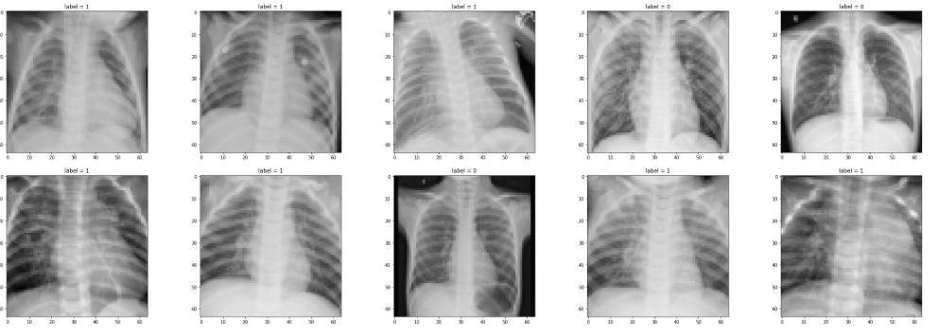

**Initial findings from exploratory analysis**

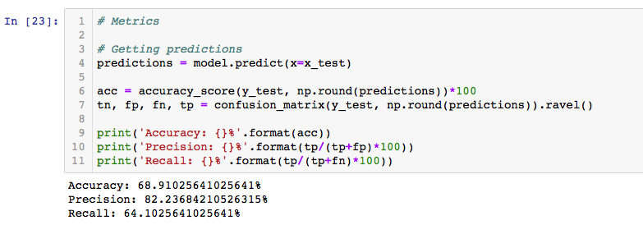

Tensorflow and Keras has discovered some connections but further analysis is required.

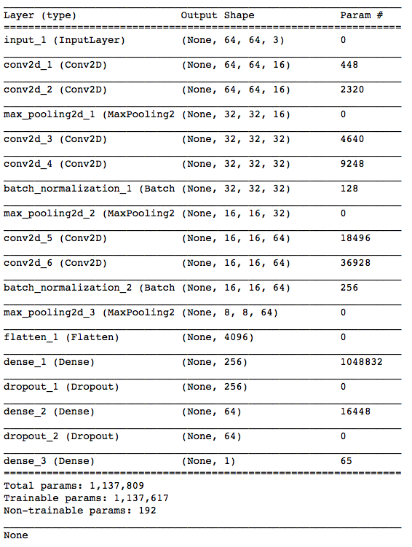

WHAT’S NEXT

Deep Dive

Incorporate second dataset of chest x-rays.

Further analysis to attempt greater accuracy and precision.

Final Report and Presentation